**Task 1: PROTOTYPE OF DESIGN OF WEBSITE IN FIGMA.**

**SLIDE 1: This slide of Figma contains ‘welcome page’ with the symbol and branding of Amazon. Here, I have attached a screenshot below.**

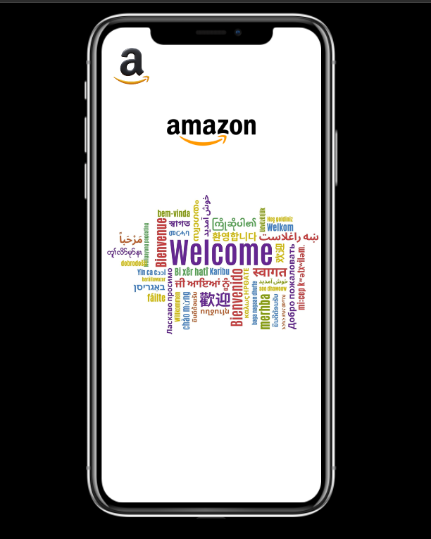

**SLIDE 2: This slide of Figma contains ‘SIGN IN page’ with email and password and finally the LOG IN button. Here, I have attached a screenshot below.**

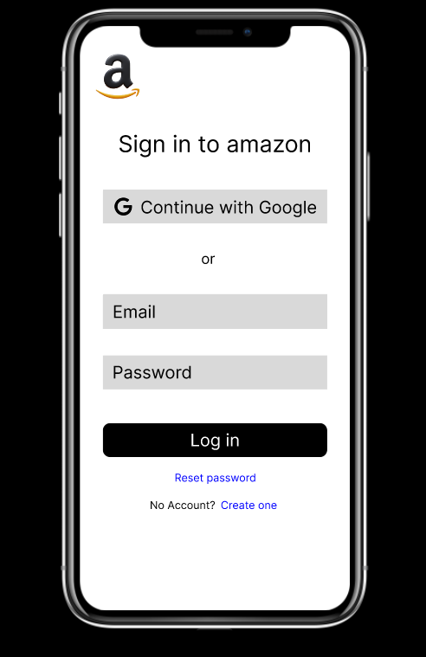

**SLIDE 3: This slide of Figma contains ‘SIGN UP page’ with email, Full Name, Phone no and password and finally the CREATE ACCOUNT button. Here, I have attached a screenshot below.**

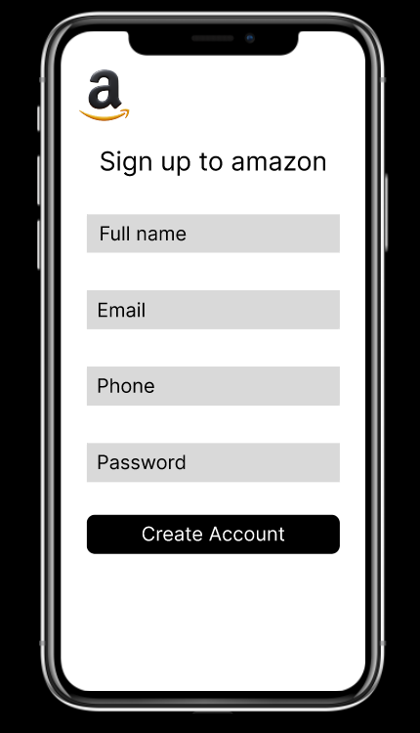

**SLIDE 4: This slide of Figma contains ‘HOME PAGE’ in which the search bar is there with the scan search features. It also contains different categories of items and products with their descriptions. It also has features like recharge and bill payment with some rewards in return. Here, I have attached a screenshot below.**

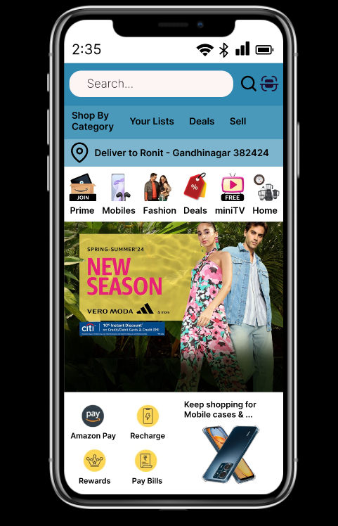

**SLIDE 5: This slide of Figma contains ‘24/7 CUSTOMER SUPPORT page’ which deals with the problems faced by the customers during their shopping, payment or order tracking issues. Here, I have attached a screenshot below.**

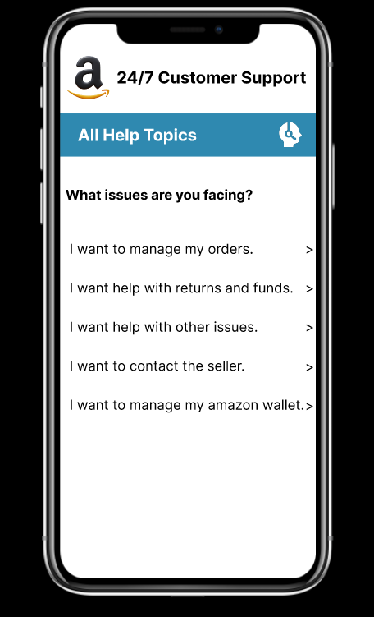

**SLIDE 6: This slide of Figma contains ‘TODAY’S DEALS page’ which shows customer the best deals on products so that it can help customer to choose the required product effortlessly and pocket friendly. Here, I have attached a screenshot below.**

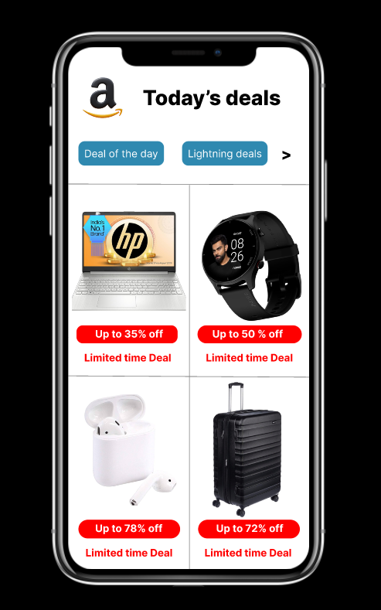

**SLIDE 7: This slide of Figma contains ‘MY CART page’ in which it contains the products which the customer has shortlisted with their description, discount on them, price and the quantity they want to select. It also contains the subtotals of the above shortlisted items with a proceed to buy button. Here, I have attached a screenshot below.**

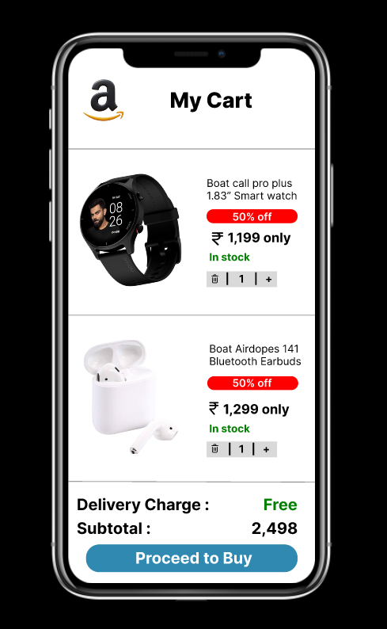

**SLIDE 8: This slide of Figma contains ‘PAYMENT page’ in which customer can select modes of payment such as Credit or debit card, UPI, EMI, Net Banking, Cash on Delivery or Amazon Wallet. It also contains the Proceed to buy button. Here, I have attached a screenshot below.**

